Module | WSQ- Business Analytics (SF)
Name | Koh Chun Yao
Date | 19 Feb 2026

Assignment-03 Submission

Task 1 - CREATE THE SALESPERSON CALCULATED TABLE

Provide screenshot of Salesperson table

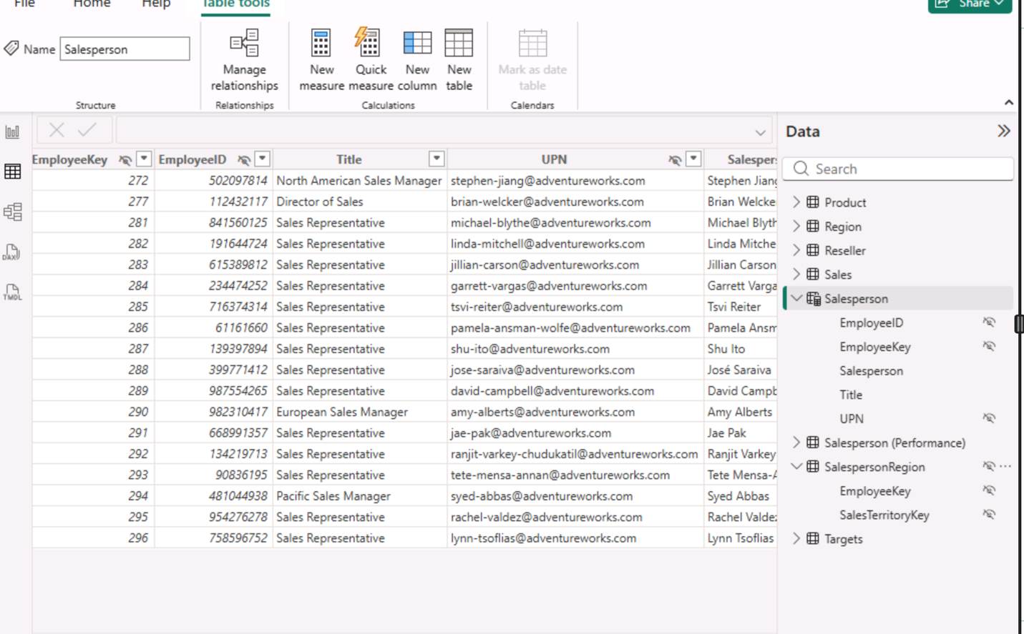

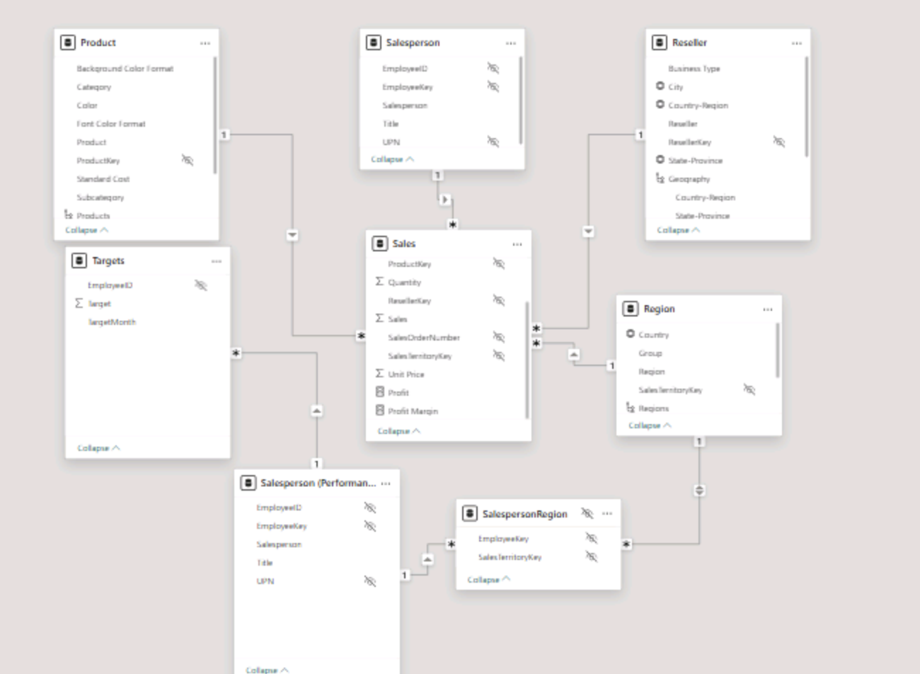

Task 2 - CREATE THE DATE TABLE

Provide screenshot of Date table with all columns and hierarchies

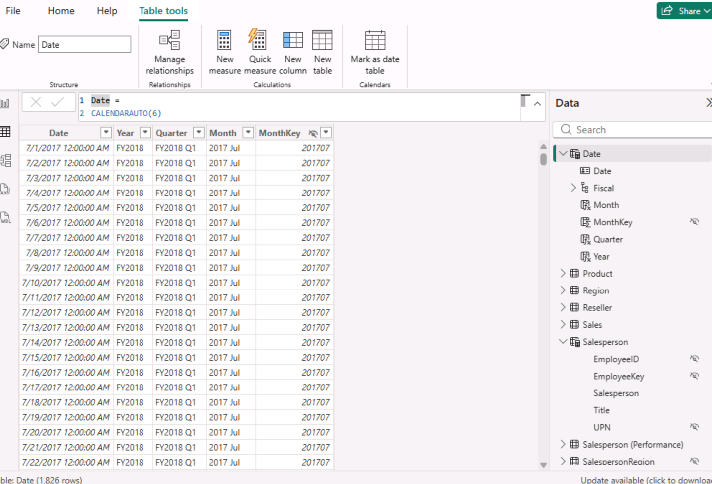

Task 3 - CREATE SIMPLE MEASURES

Provide screenshot of created measures.

